Checkweigher Workflow

The checkweigher has the following hardware:

Input: Weight Module, Photo Eye, Camera

Output: Motor Drive, Pushing Arm

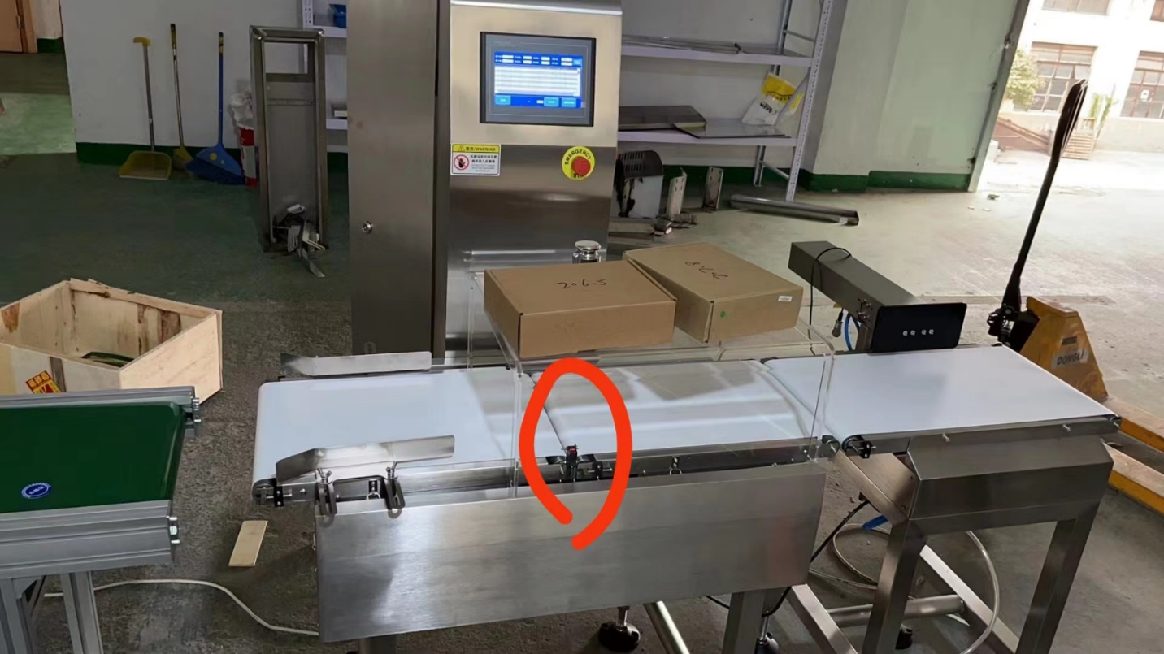

Here’s the User Settings:

1. The user can set up the speed of the motor drive, which is controlling the speed of the conveyor.
2. The user can also set up the delay time for the pushing arm to fine tune the timing of the arm.
3. The user can calibrate the scale.
4. The user can set up the acceptance range of the products. Such as 10.0 lbs to 10.2 lbs.
5. There is Run, Pause and Stop/Reset button on the screen.

Here’s the Workflow:

When the setup is done, the user press “Run”, the conveyor will start moving. According to the above picture, the boxes will be placed on the left side then move to the right side.

When box passes the photo eye (it is circled in red in the above picture), the system will record the time as Time0. When the box goes through the scale, based on the weight, the system will determine if the box weighs within the acceptance range or not. If yes, the system will let the box go through without doing anything else. If no, the system will trigger the pushing arm to push the box out of the conveyor. To calculate the timing of the pushing arm, it will be calculated as the distance between the photo eye and the pushing arm (D) divided by the speed of the conveyor (S) with the adjustment of the delay settings.

The system will count the numbers of the boxes which are out of the range (Defective Rate). It is a real time display showing the defective number/total number of each batch. Once the Stop/Reset button is pressed, it will start a new batch (from zero). The Pause button will stop the operation but will not start a fresh batch.

The use can also run a batch report and daily report or customize range report for the defective rates.